Weapons Identification Task (WIT)

The WIT will be administered using E-Prime and will be composed of a practice block and an experimental block, as outlined in Payne (2001). In each trial, a prime is presented, followed quickly by the presentation of a target. Participants will be given one of two versions. In both versions, primes consist of 4 photographs of Black males’ faces and 4 photographs of White males’ faces. The faces have neutral expressions and are cropped to exclude peripheral features (e.g. hair, clothes). In Version 1, targets consist of 4 photographs of handguns and 4 photographs of hand tools (e.g. pliers, socket wrench). In Version 2, targets consist of 4 photographs of handguns (identical to version 1) and 4 photographs of neutral items (e.g. a giraffe, a banana).

The practice block is composed of 16 trials. A trial is composed of the presentation of a prime for 200 ms, followed immediately by a target, which is masked after 200 ms. The mask remains on the screen until the participant responds. Participants are instructed to only respond to the second picture. Participants are asked to categorize each target as a gun or a tool (Version 1) or as a gun or a non-gun (Version 2) as quickly as they can using two keys on a keyboard. Participants have a 500 ms response deadline following the presentation of the target. If they take longer than 500 ms to respond, “TOO SLOW” will appear in red on the screen for 1 s before they are allowed to go on to the next trial. The experimental block is composed of 240 trials, with 60 trials of each critical prime-target pairing. The presentation of the trials will be randomized.

Prime picture examples:

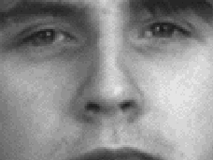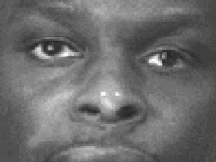

Target picture examples (Version 1):

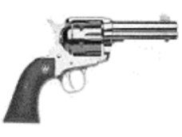 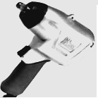

Target picture examples (Version 2):

